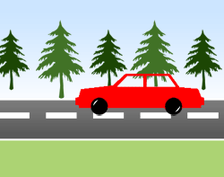
This Photo by Unknown Author is licensed under CC BY-SA-NC
- In this picture list as many “frame of references” you can.
- Provide an example of “relative motion”
- How is frame of reference used to measure motion?

- Compare the term “displacement” and “velocity”. Please state in at least 2 sentences how these two terms are similar.

- Matchbox car activity – calculate average speed

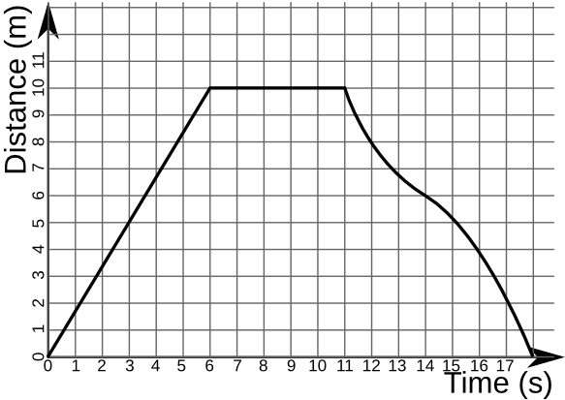
This Photo by Unknown Author is licensed under CC BY-SA

- What is the average speed between 6 and 11 seconds?
- What is the average speed between 0 and 4 seconds?
- What is the average speed between 0 and 6 seconds?
- Explain the difference between velocity and speed.

- Displacement vectors of 4km south, 2 km north, 5 km south and 5km north combine to make a total displacement of_________________.

Name_____________________________________________Date_____________________
11.1 & 11.2 reading quiz
1. Speed is the ratio of the distance an object moves to
a. the amount of time needed to travel the distance
b. the direction the object moves
c. the displacement of the object
d. the motion of the object

2. Velocity is a description of both
a. acceleration and displacement
b. speed and acceleration
c. speed and direction
d. distance and slope

3. To describe motion a __________________ is necessary.
a. distance
b. relative motion
c. frame of reference
d. none of the above

4. The slope of a distance time graph is equal to
a. speed
b. acceleration
c. displacement
d. motion

